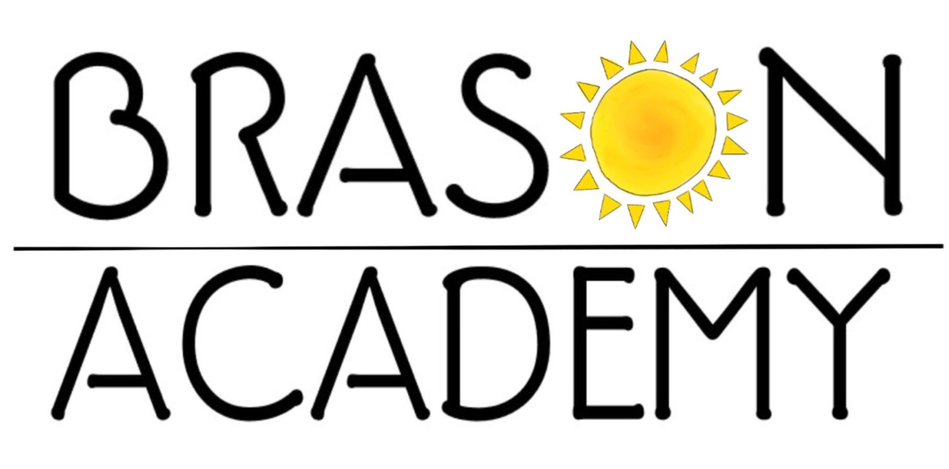

**Academic Calendar 2018-2019**

Family Day-Feb 18,2019

March Break - 11-15, 2019

Good Friday-Apr 19,2019

Easter Monday-Apr 22, 2019

**Victoria Day**– May 20, 2019

**Canada Day**- Jul 1, 2019

**Civic Day-** Aug 5, 2019

Professional Development Days

October 26, 2018 Jan 25, 2019

November 16, 2018 May 31, 2019

Jun 28, 2019

Additional dates to remember

September 4, 2018 First day of school

October 24, 2018 Term 1 field trip

October 26, 2018 Parents Workshop/Information evening-1

October 31, 2018 School Halloween party

November 12-16, 2018 Watch me work -1

December 7, 2018 Reports go home

December 12-14, 2018 Parent Teacher Conference

December 21, 2018 Last day of Term 1

January 7, 2019 First day of Term 2

January 25, 2019 Parents workshop/information eve-2

February 1, 2019 School Photo Day

March 12-16, 2019 Heritage/Diversity Week

Statutory Holidays

**Labour Day**– Sep 3, 2018

**Thanksgiving**– Oct 8, 2018

**Winter Break**– Dec 24, 2018

- Jan 4, 2019

March 25, 2019 Re-enrolment for 2019-20

April 15-19 Watch me work - 2

April 22, 2019 Earth Day

June 6, 2019 Term 2 Field Trip

June 7, 2019 Reports go home

June 20, 2019 Parent’s Appreciation Day Picnic 5.30-7.30

June 12-14, 2019 Parent Teacher Conference

June 27, 2019 End of year celebrations and last day of school for CASA

July 2, 2019 Summer camp for CASA (pending enrolment)

August 23, 2019 Last day of school for toddlers and CASA

September 3, 2019 School reopens for the new academic year